**BACkEND / LARAVEL**

1. Composer update
2. Copy the env example and make it .env
3. php artisan key:generate –force
4. create the db in msql
5. php artisan migrate
6. php artisan db:seed
7. php artisan migrate:fresh ---seed

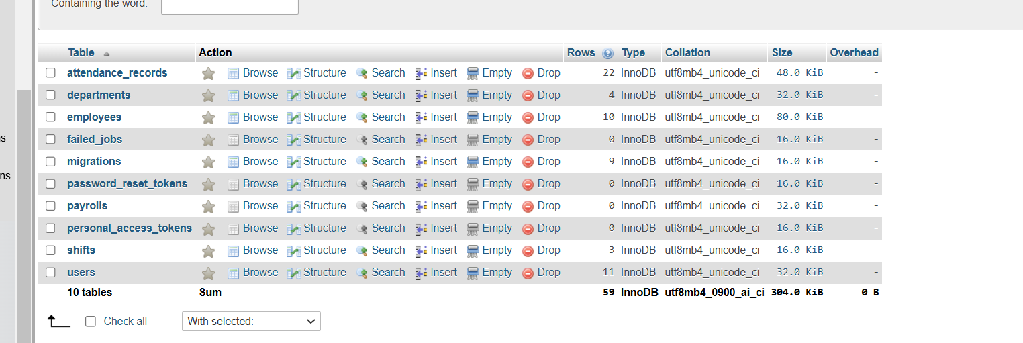

**API**

**I have used swagger you will find all the API documentation there.**